LAB 3

Implement the following relationships from Caveat Emptor:

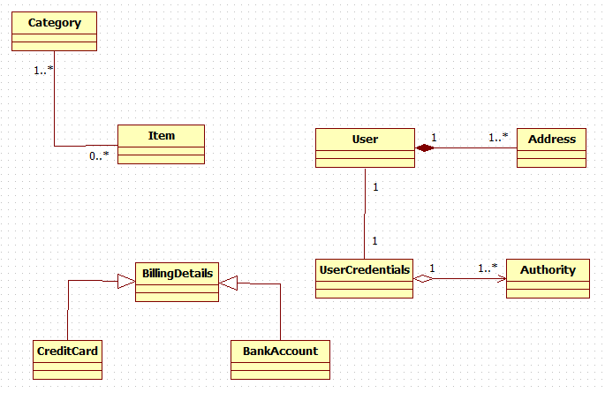

See the attached .zip file. It has the relevant domain objects & DAOs & Services.

Ensure associations are validated by the queries provided [similar to the class demos].

**The Inheritance is OPTIONAL…**

**EXPECTED OUTPUT:**

